Meeting minutes for Vanderkloof Dam Fisheries Project
27 January 2017
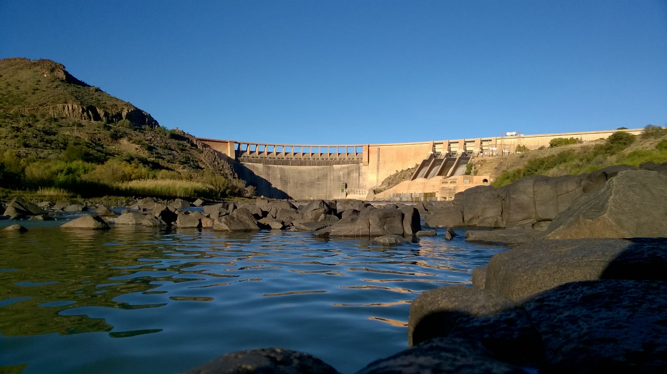

Vanderkloof Fisheries Advisory Group Meeting: Final record of decisions (ROD)
Venue: Department of Water and Sanitation, Vanderkloof

Date: 27 January 2017

- Opening Statement by Thinus Jonker, Chairperson of the AG

Mr Thinus Jonker opened the meeting with the following statement: “Best wishes for 2017 and I hope you are blessed with laughter, energy and happiness in the New Year! I am not one for long speeches, but I want to take some time to reflect on our progress. If I touch on agenda points we will discuss it as on the agenda.

This group has come a long way since we started more than two years ago and it has not been an easy road we were travelling on. There have been some heated discussions, long and tiresome debates. Many times I thought of quitting, but the unpleasant incidents have taught us lessons and added to our experience. At the previous meeting I really thought that we were making substantial progress, only to be pulled down by a number of incidents and numerous e-mails going around in December and January. As the chairperson of this meeting, it has been difficult to remain impartial and allow long speeches going in circles and not adding value to the process. I have however realized that it has given everyone the opportunity and recognition for their contribution in the development of the EFMP. Something that has also been a burden to date has been threats and counter threats by members of this Group and I feel serious about this issue – if a member wants to take the legal route and/or to make attacks on the decisions of the group through the media, it is your constitutional right, but please withdraw from the group. This groups’ functionality depend on co-management of the project and trust and collective decision making are therefore vital for successful implementation.

DENC has issued the exemptions for the experimental fishery (I want to emphasize the word ‘experimental’ - relating to tests, especially scientific ones or based on untested ideas or techniques that has not yet been established or finalized). These exemptions are the product of what we set out to do and might not be exactly as we would have like to see it, but we are not going to debate it again. We need to move into the implementation phase and we will certainly be confronted by challenges related to the exemption conditions. We will have to address these as and when it arises.

I also feel that it is time to agree on a short Terms of Reference for the group that will provide guidance on the functions and processes of the group. This might have been an omission on our side in the beginning, but as the saying goes rather late than never!

- Attendance & Apologies
Mr Steven Nhbalathi, DWS
Mr Dries Visser, DWS
Mr Mantombi Bongo, FS-DARD
Mr Zandile Moloi, FS-DARD
Mr Andre Swart, NC-DALRRD
Ms Roberta Burgess, NC-DALRRD

The SAPS of Vanderkloof was invited to the meeting, but did not attend.

The Vanderkloof Angling Club resigned of the Advisory Group. Therefore Caroline Badenhorst will not form part of the committee. The letter of resignation in Appendix 2.
The Vanderkloof Rate Payers Association stated that Ms Caroline Badenhorst will be assisting them and therefore will continue to take part in the AG.

- Previous Meeting Minutes have been approved (apart from correction of the email addresses of some of the AG members)

- Report back from DENC regarding the permit / exemption application for the experimental fishery on the dam and Formation of an implementing sub-committee

4.1 The exemption Permit for the Experimental Fishery have been approved by NC-DENC.
The AG decided that Mr Henry Pampier from DENC-Roelfointein will be assisting with the monitoring and compliance of the kraal fishers.
4.2 SACRAA/ SASACC disagree with the issuing of the permit exception for the experimental fishery and indicated that they plan to follow up.
4.3 The AG ratified the formation of a subcommittee for the implementation of the Project formed by NC-DARRLD, DENC, Rhodes University, Local Municipalities, Masifundise Development Trust and the fishers’ representatives. The implementing subcommittee will deal with the everyday tasks and issues related to the project. It will meet more often the AG and progress reports will be available to the other AG members.

- Report back from DAFF as the chair of the sub-committee to develop the permit conditions for the kraal permits.

Mr Kishan Sankar from DAFF, chairperson of the subcommittee for the kraal reported that senior DAFF officials are currently looking at the final comments and will report back within two weeks.

- Report back from DWS / Masifundise regarding the risk assessment report and lights regarding the kraals.

6.1 DWS and Masifundise reported that they have found an agreement on the pending issues of the Indemnity Agreement, that is now in the process of finalization by DWS. The Indemnity Agreement is only applicable to the Security Zone of the Dam and it is only valid for the period of the project.

6.2 DWS is in the process of fixing the lights but it still will take few months. Fishers can find alternative sources of illumination in the meantime.

- Discussion regarding recent issues relating to the kraals

7.1 Rhodes and Masifundise reported on the additional kraals that have been built in the project areas. Qurban Rouhani (Rhodes University) reported that in its first visit at the kraals he had been denied access to the Security Zone and therefore he mapped Kraal 1 using Google Earth. However, fishers argue that they never had an opportunity to show Mr Rouhani that Kraal 1 was not just one kraal but a complex of kraals – which over time was built and destroyed many times over during their encounters with the authorities. The fishers however did acknowledge that hey had built new kraals after the process had begun. Some of these new kraals were built by fishers within the process and some outside the process (free agents).

Masifundise explained that the fishers agreed that they would destroy the extra new kraals built after the process which have no historical connections (this has already begun). However, the kraal fishers requested that the new kraals built by the free agents should be brought down by DENC officials. The fishers are private citizens and as such they do not have the right to take the law into their hands and destroy other peoples property.

Masifundise argued for the maintenance of the historical kraals.
The AG agreed that to find a solution to this issue the new kraals should be mapped by Mr Henry Pampier (DENC), together with the fishers and Mr Rouhani . NC-DARRLD will also contribute to the survey of the kraals to determinate their historical presence. Once this report is ready, the AG will take a decision on this matter.

7.2 Rhodes and Masifundise reported on the issue of the dead fish. The presence of dead fish at the kraals has been the result of a breakdown in communications within the 3 communities that operates at the kraals. Masifundise intervened to restore the communications and it is in the process to secure that a clear management plan is in place to harvest the kraal regularly and avoid fish loss. Masifundise pointed out that this is also related to the difficulty that fishers might encounter in getting to the kraals due to lack of transportation. Furthermore, fishers argued that some of the fish naturally dies due to the lack of oxygen and to the turbines at the Dam.
The AG agreed on exploring the issues from different angles. From a technical side, the engineers of NC-DARRLD will visit the kraals to assess if it is possible to design kraals in a way that fishes could escape the kraals. These ideas will then be workshopped with the fishers before making a final decision. The fishers should manage the kraals according to a plan that results in increased security and accountability. The soon to be appointed Fishery Officer will also conduct a study to assess the natural causes of death for the fish. If there are any kraals that are not used, they should be destroyed.

7.3 The Ratepayers Association has raised questions regarding the criteria to define a kraal fishers. Masifundise replied that is already in the process of addressing this concerns

- Discussion to further formalize the AG and developing a defined TOR & code of conduct for the members of the AG.

Rhodes University reported that some of the Departments involved in the Vanderkloof Fisheries Project requested the development of defined terms of reference and code of conduct that will apply to all the members of the AG. A draft will be soon circulated for comments among the members of the AG.

- Additional matters
9.1 Response to Mr Barkhuizen’s Letter from Masifundise

Masifundise responded as it follows: “My name is M, I am 10 years old, and I live behind the hill, in the township of Keurtjieskloof. I cannot see the dam, nor the light of the cross. The hill is in my way. I live in the shadow of the hill.
My father is a fisherman, he fishes with an old trusty rod, fixed, but workable, and he collects fish from the kraals. I know that my father loves fishing, but he does not do it for fun – He fish for food. Without the fish, we have only bread or pap to eat. If my father catches enough fish, we have money for electricy, bread and milk.
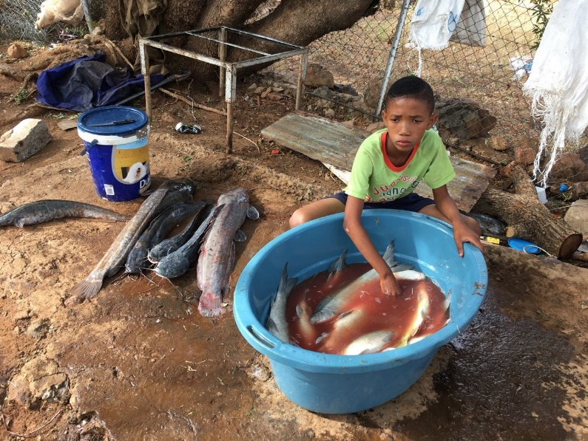
I live behind the hill, I cannot see the dam, nor the light of the cross.
When my father goes to fish, I look out for him, watching to see him make his way over the hill, with his catch in one hand and rod in the other. I know he has to past the towns dump to my township. The symbolism that the towns dump was placed behind the hill, on the road to my township is not lost on me.
When I see my father struggling up that hill, I know that his catch was small and I can see that his spirit is low.. Its funny, I have noticed, that when his catch is big and heavy, the hill seems to shrink… my father looks happier. But, the hill is always there, keeping my eyes away from the dam and in darkness from the light of the cross. I wish somebody could remove this hill.
The hill is always on my mind, and what lies on the other side…. I imagine people busy with work, living. But I wonder if they think of me, existing, behind the hill. Maybe they see me when they drive to the dump to throw out their waste. It’s the road to my home. I wonder if they notice me.
A few years ago, I heard my father tell me mother that things may change for us, but it will take time. I heard my father say that he may in the future if be able to own a boat…. And be able to fish behind the hill. I remember thinking, maybe my dad will also own a bakkie….like I see passing by at the road, leading to our community. I often see little white boys, with their fathers….they look so happy sitting at the back of their shiny big bakkies, some with their dogs…..going to the river to fish….I thought, maybe one day , we could do that as well.
For almost 3 years, I have heard my father and the other fishes talk about change coming, and I was excited, my mother said that if I studied hard at school, I may be able to go to university, I’d really like that, so that I could help my brothers and sisters to study as well.
Over the years, I heard my father was using words like co- management, code of conduct, management plans, scientific plans…. human rights, equality, and I was feeling so proud of him. I often hear him say that it is difficult to work in an organised way, because not all the fishers get it, but that those who did must be patient with the others.
BUT, a few days ago, I heard my father tell my mother about a letter from a BIG man from the FREE STATE wrote. My father was stressed and this stressed my mother as well. I heard something about him saying that this project that my father and others were working towards is going to fail and should be stopped, because other similar projects have failed. I thought about the boys and girls in that other communities. I wonder what they ate. Because we will not have food if this project would stop.
I heard my father say that on Friday… many BIG men and women will have a meeting at the BIG building behind the hill. I wish I could be there. It will be at school, but my thoughts will be on the meeting at the BIG building behind the hill.
I don’t understand why this is happening. I’m only 10 years old. Why can’t my father and the other fathers be giving a chance to make this project work. I heard some whispering that it is the rich people who come to the dam to have fun who is trying to stop this project.
I cannot understand why…I was told that we were all equal, so why do some have and others not….and why don’t those who have share what they have.
HELP me understand.
I live behind the hill and I cannot see the dam or the light of the cross.
Can someone please move the HILL...?
In response to Leon’s email
We do not expect and understand, how government officials can act outside the process their department has committed to. These actions break trust….and your motive is questionable.
The apartheid legacy is still affecting us through legislation, dismissing it, is VERY insensitive. Many projects HAVE failed because of that legislation.
Delegitimizing the EFMP as not scientific, undermines the hard work done by the AG in the last two years, and the commitment of those who are striving to make it work.
There is no room for unilateral actions in co-management. Threatening to take unilateral action is unacceptable, especially from a Gov official.
Tone of the letter, is concerning. That fishers (main recipient of the project) were not included but others were, SPEAKS VOLUMES.
Our role in the AG is to contribute to find solutions, not to be destructive towards the process.”

Mr Leon Barkuizen ensured his commitment to the project and to the development of inland small-scale fisheries.

9.2 Appointment of Fisheries Officer

Rhodes University reported that they are in the process of shortlisting the candidates for the Fisheries Officer appointment. Nevertheless, to proceed with the appointment is necessary for the funds to be released.

- Next meeting and closure

The next AG meeting will be on Thursday, the 30th of March at 10 am.

Appendix 1- Attendance Register
Full Name and Surname | Organization | Email Address | Contact Number
Jaby Mokogna | DWS | Mokogna62@dwa.gov.za | 0829062768
Carmen Mannarino | MDT | carmen@masifundise.org.za | 0712833179
Warwick Sauer | Rhodes | w.sauer@ru.ac.za | 0827741337
Qurban Rouhani | Rhodes | q.rouhani@ru.ac.za | 0824455700
David Paulse | DENC | permits@vodamail.co.za | 0823357713
Leon Barkhuizen | FS DESTEA | barkhl@detea.fs.gov.za | 0832569446
JH Josling | FS DESTEA | joslingj@detea.fs.gov.za | 0828869145
Abriee Coetzee | DWS | coetzeea@dws.gov.za | 0828055913
Nelly Ndumo | DWS | Ndumon@dws.gov.za | 0827417302
TW Joxo | DWS | joxow@dws.gov.za | 0837971558
Nico Waldeck | MDT | nicodwal@gmail.com | 0605044177
Kishan Sankar | DAFF | kishans@daff.gov.za | 0832256416
Archie Hlungwani | DAFF | Archie.hlungs@gmail.com | 0834779238
Ntombi Mokgalagadi | DALRRD | nyende@ncpg.gov.za | 0825597289
Kgabo Ramovoka | DWS | ramorovokak@dws.gov.za | 0605200662
Clarence Oliphant | SSF | Luceladams@gmail.com | 0847251468
Johannes Coetzee | SSF |  | 0763721683
JP Benadie | SSF |  | 0787767989
Raphael J Benadie | SSF |  | 0745799336
Lorenzo Danster | SSF |  | 0791066452
Caroline Badenhorst | RPA | badenhorstd@yahoo.com | 0845053667
Len De Jager | VRPA | lendejager@gmail.com | 0833708862
Bernard Venter | SASACC | bverts@justice.gov.za | 0834442790
Aidan Wood | SACRAA | tagfish@telkomsa.net | 0828694939

Appendix 2- Vanderkloof Angling Club Resignation Letter
